DATABASE MANAGEMENT SYSTEM LAB FILE

NAME- Arjun kulshrestha

ROLL NO- 007

SECTION-IB

**Exercise No.-1**

**TITLE: CREATION OF TABLES**

**1)Create a table called student I'd with the following structure.**

|  |  |
| --- | --- |
| NAME | TYPE |
| Empno | Number |
| Ename | Varchar2(20) |
| Job | Varchar2(20) |
| Mgr | Number |
| Sal | Number |

Queries

1. Add a column commission with the domain to the employee table.
2. Insert any five records into the table.
3. Update the column details of job.
4. Rename the column of employee table using alter command.
5. Delete the employee whose empno is 05.

**Objective: Implement the basic knowledge of SQL queries and relational algebra.**

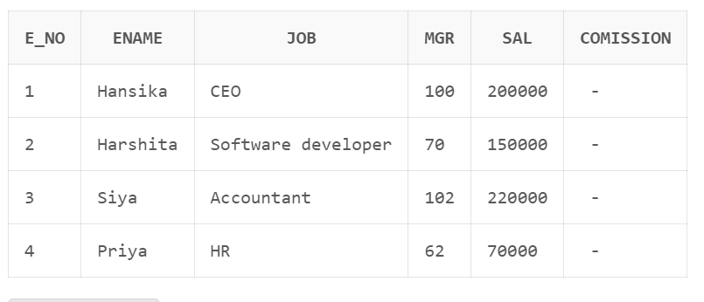

**Pre-requisites: Basic understanding of SQL**

**SOLUTION:**

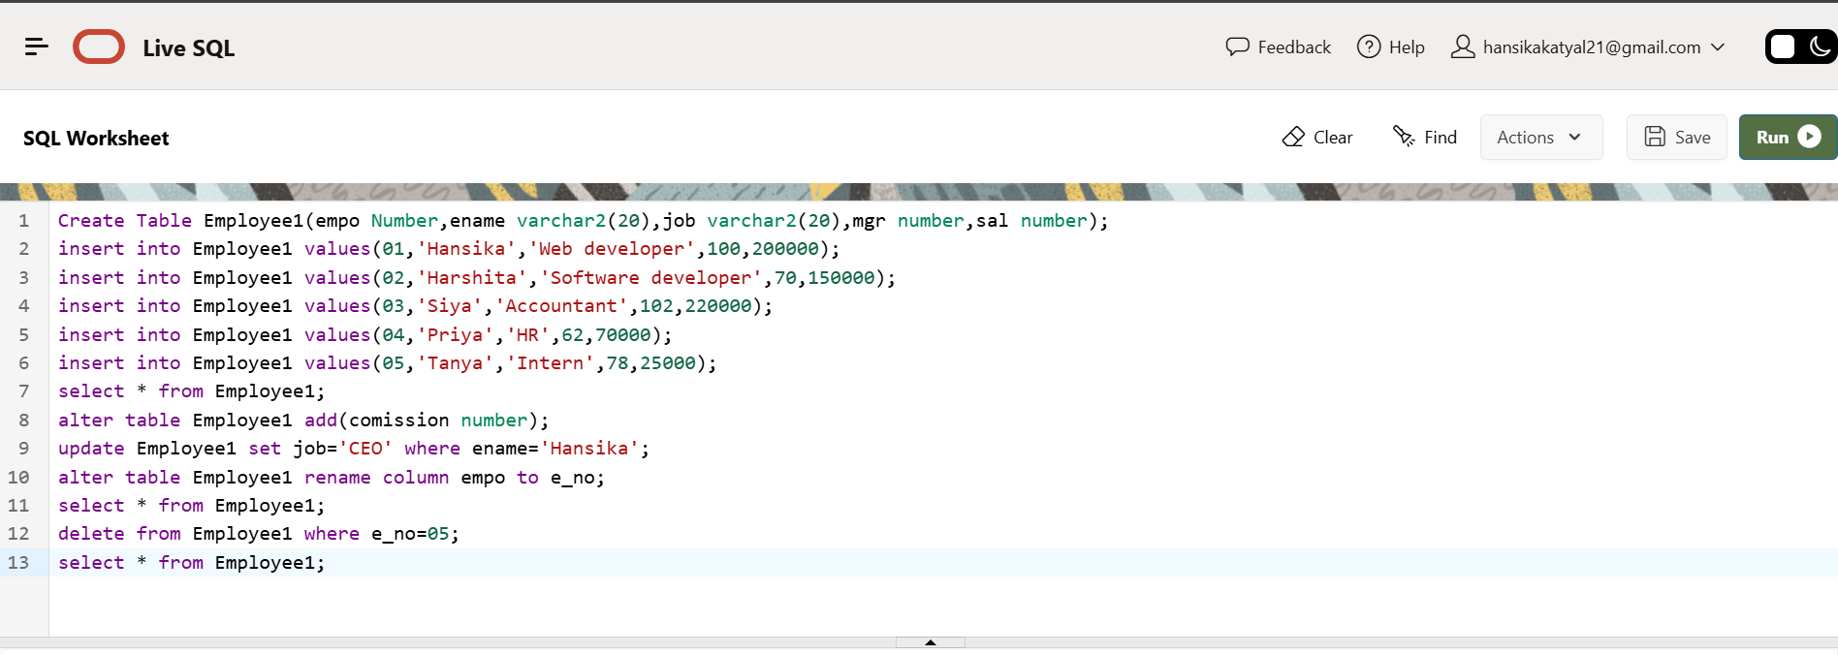

**Exercise No.-2**

**TITLE: CREATION OF TABLE**

2) Create department table with the following structure.

|  |  |
| --- | --- |
| **Name** | **Type** |
| Deptno | Number |
| Deptname | Varchar2(20) |
| Location | Varchar2(20) |

Objective: Implement the basic knowledge of SQL queries and relational algebra.

Pre-requisites: Basic understanding of SQL

**SOLUTION:**

a. Add column designation to the department table.

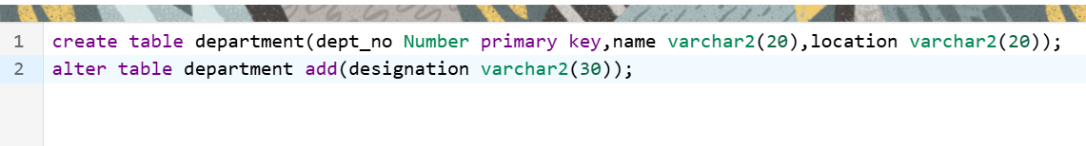

b. Insert values into the table. 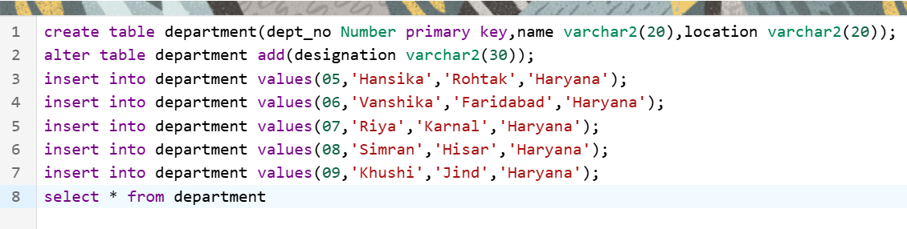

Output:

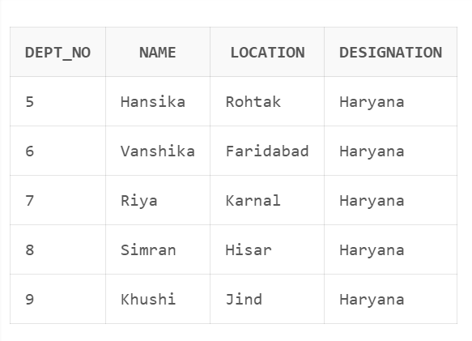

c. List the records of emp table grouped by deptno.



Output :

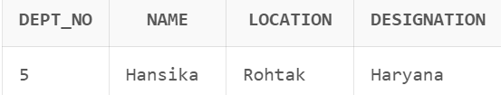

d. Update the record where deptno is 104.



Output:

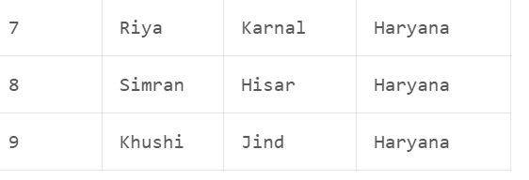

e. Delete any column data from the table.

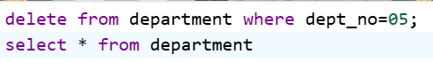

Output:



Exercise No.-3

**TITLE: CREATION OF TABLES**

**3)** Create table called customer table.

|  |  |
| --- | --- |
| **Name** | **Type** |
| Cust_name | varchar2(20) |
| cust_street | varchar2(20) |
| cust _city | varchar2(20) |

**Objective: Implement the basic knowledge of SQL queries and relational algebra.**

**Pre-requisites: Basic understanding of SQL**

**SOLUTION:** 

Output:

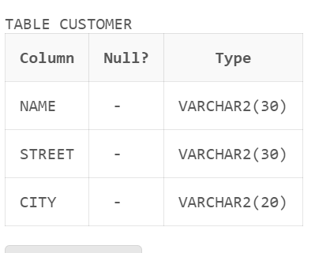

1. Insert records into the table.

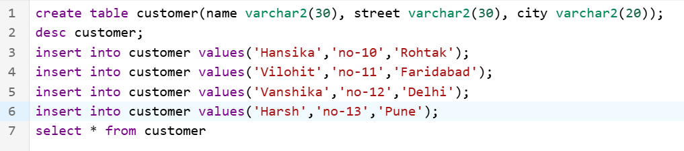

Output:

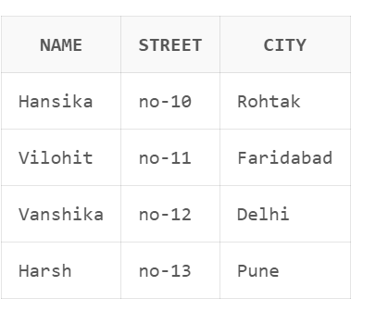

1. Alter the table column domain.

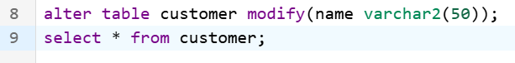

Output:

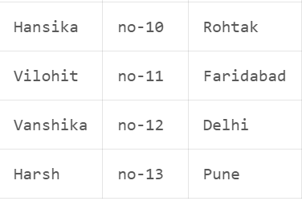

1. Add salary column to the table.

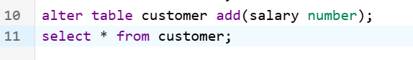

Output:

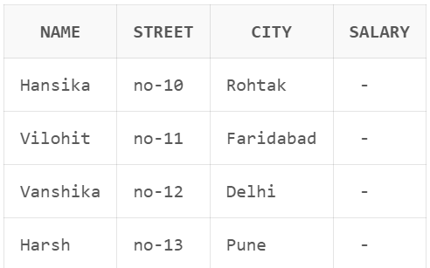

1. Drop salary column of the customer table.

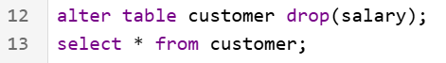

Output:

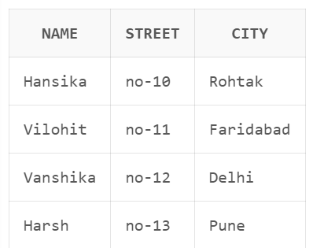

1. Delete the rows of customer table whose cust_city is ‘hyd’.

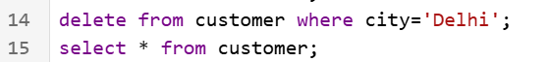

Output:

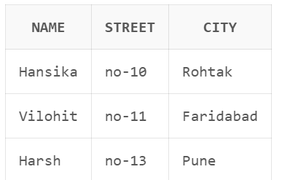

**Exercise No.-4**

**TITLE: CREATION OF TABLES**

**4)** Create table called branch table.

|  |  |
| --- | --- |
| **Name** | **Type** |
| Branch name | Varchar2(20) |
| Branch city | Varchar2(20) |
| Asserts | Number |

**Objective: Implement the basic knowledge of SQL queries and relational algebra.**

**Pre-requisites: Basic understanding of SQL**

**SOLUTION:**

1. Increase the size of data type for asserts to the branch.

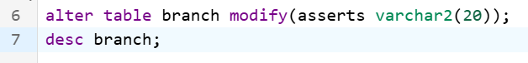

1. Add and drop a column to the branch table.

Add:

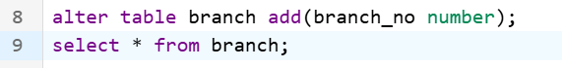

Output:

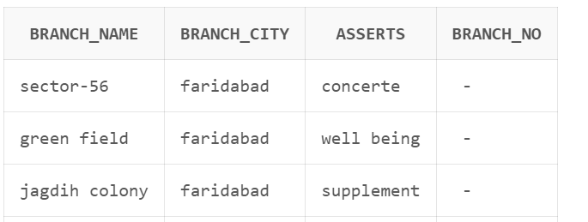

Drop:

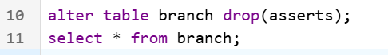

Output:

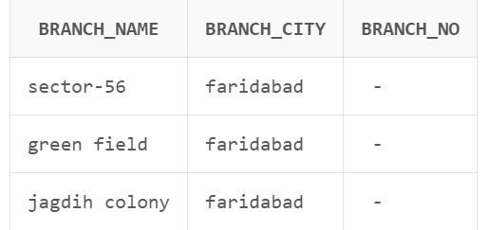

c. Insert values to the table.

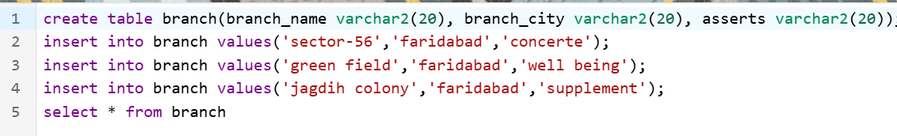

Output:

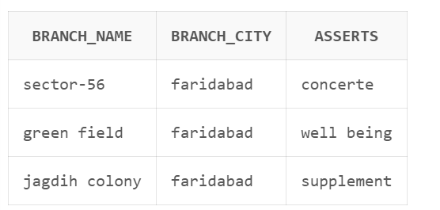

1. Update the branch name column.



Output:

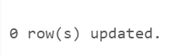

1. Delete any columns from the table.



Output:



**Exercise No.-5**

**TITLE: CREATION OF TABLES**

5) Create a table called sailor table.

|  |  |
| --- | --- |
| **Name** | **Type** |
| Sid | Number |
| Sname | varchar2(20) |
| Rating | varchar2(20) |

**Objective: Implement the basic knowledge of SQL queries and relational algebra.**

**Pre-requisites: Basic understanding of SQL**

**SOLUTION:**

For creating table



A . Add column age to the sailor table.

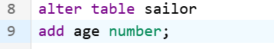

1. Insert values into the sailor table.

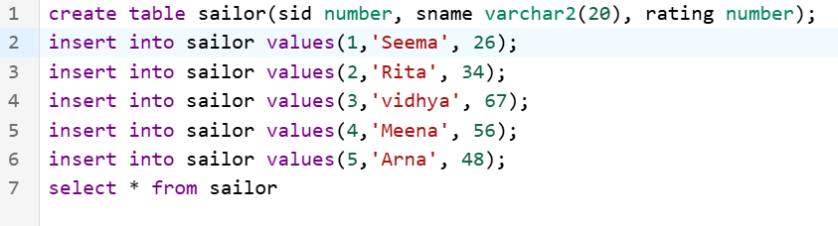

Output:

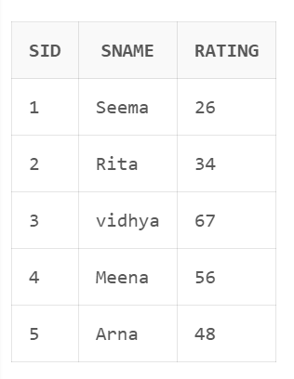

1. Delete the row with rating



Output :



1. Update the column details of sailor.



Output :

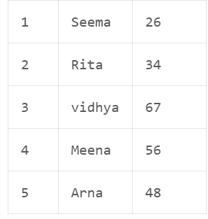

1. Insert null values into the table.



Output :

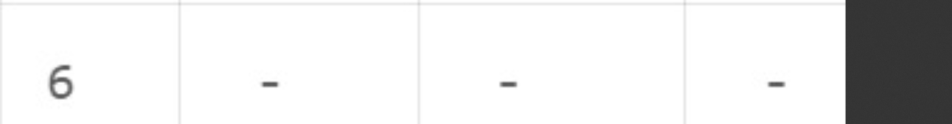

**Exercise No.-6**

**TITLE: CREATION OF TABLES**

6) Create a table called reserves  table.

|  |  |
| --- | --- |
| **Name** | **Type** |
| Boat id | Integer |
| Sid | Integer |
| Day | Integer |

For creation of table :



1. Insert values into the reserves table.

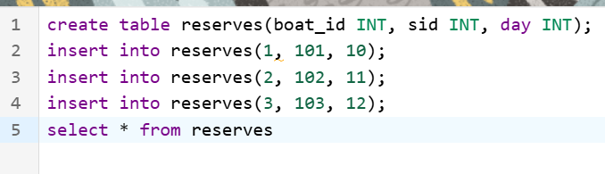

Output :

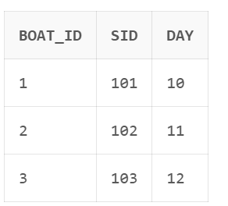

b. Add column time to the reserves table.



Output :

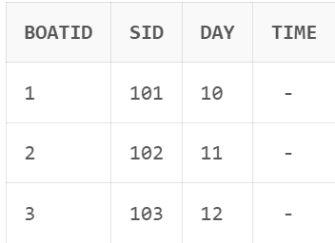

1. Alter the column day data type to date.



1. Drop the column time in the table.



Output :

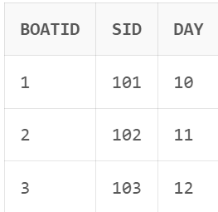

1. Delete the row of the time table with some condition.



Output :

